Standardization (Z-score Scaling)
Standardization transforms data to have a mean of 0 and a standard deviation of 1.
It centres data around the mean, useful for algorithms that assume normally distributed data.
• Formula: Z = (X - μ) / σ
Criteria: Any data point whose Z-score falls out of 3rd Standard Deviation is an outlier treatment.
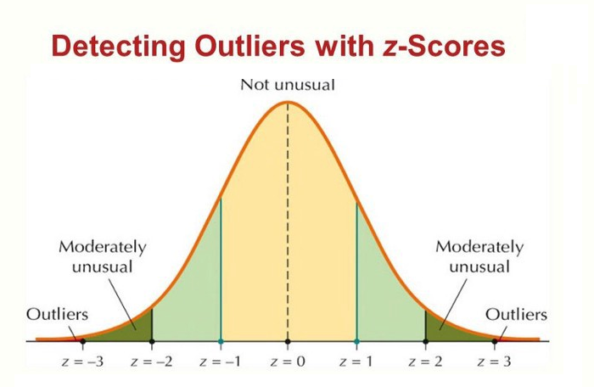

Standard Deviation: A statistical measure that quantifies the dispersion or spread of data points relative to their mean (average).
A low standard deviation indicates that data points are clustered closely around the mean, representing high “consistency”, while a high standard deviation shows that data points are spread out over a “wide range”.
Eg: If a dataset has a mean 10 and a standard deviation of 1, most data points are close to 10 (i.e. 9,10,11). If the standard deviation is 5, the data points are much more spread out (i.e. 5,10,15).

Real-Life Insight
Z-Scores are widely used in:
- Education: Comparing student performance across different exams.
- Finance: Detecting unusual stock price movements.
- Healthcare: Standardizing test results like BMI or cholesterol levels.

Scenario: Exam Scores in a Class
A professor wants to understand how well a student performed compared to the rest of the class.
- The class average (mean) score = 70
- The standard deviation (σ) of scores = 10
- The student’s score = 85
The professor asks: “How far above average is this student’s score in terms of standard deviations?”

Step By Step Solution:
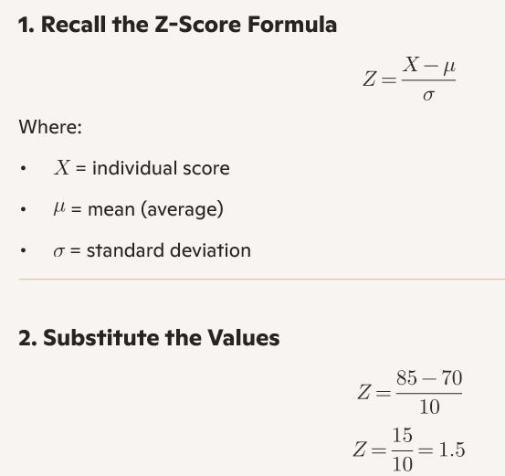

3. Interpret the Result
- A Z-Score of 1.5 means the student scored 1.5 standard deviations above the mean.
- In practical terms, this student performed better than about 93% of the class (using the standard normal distribution table).
- Final Answer
- The student’s Z-Score = 1.5, which shows they performed significantly above average compared to their peers.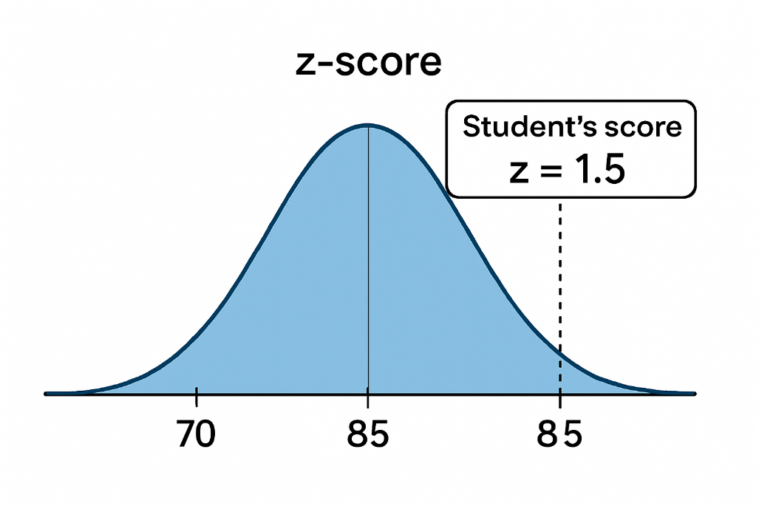
Here’s the visual you asked for — the bell curve clearly marks the student’s score at +1.5σ above the mean:
This diagram shows:
- The mean at 70 (center of the curve).
- The student’s score at 85, represented by the dotted vertical line.
- The shaded region to the left of 85, which covers about 93% of the distribution, meaning the student outperformed most of the class.
This kind of visualization makes Z-Scores much easier to interpret since you can instantly see where a score lies relative to the average.

Here’s a comparative bell curve showing both positive and negative Z-Scores:
- The mean is at 70.
- The student’s score of 85 is marked at +1.5σ, showing above-average performance.
- A second score of 55 is marked at −1.5σ, showing below-average performance.
This visual helps you see how Z-Scores reflect relative standing in a distribution — whether someone is outperforming or underperforming compared to the average.

Here’s the comparative Z-Score diagram —
it visually contrasts a student scoring +1.5σ above the mean (score of 85) with another scoring −1.5σ below the mean (score of 55):
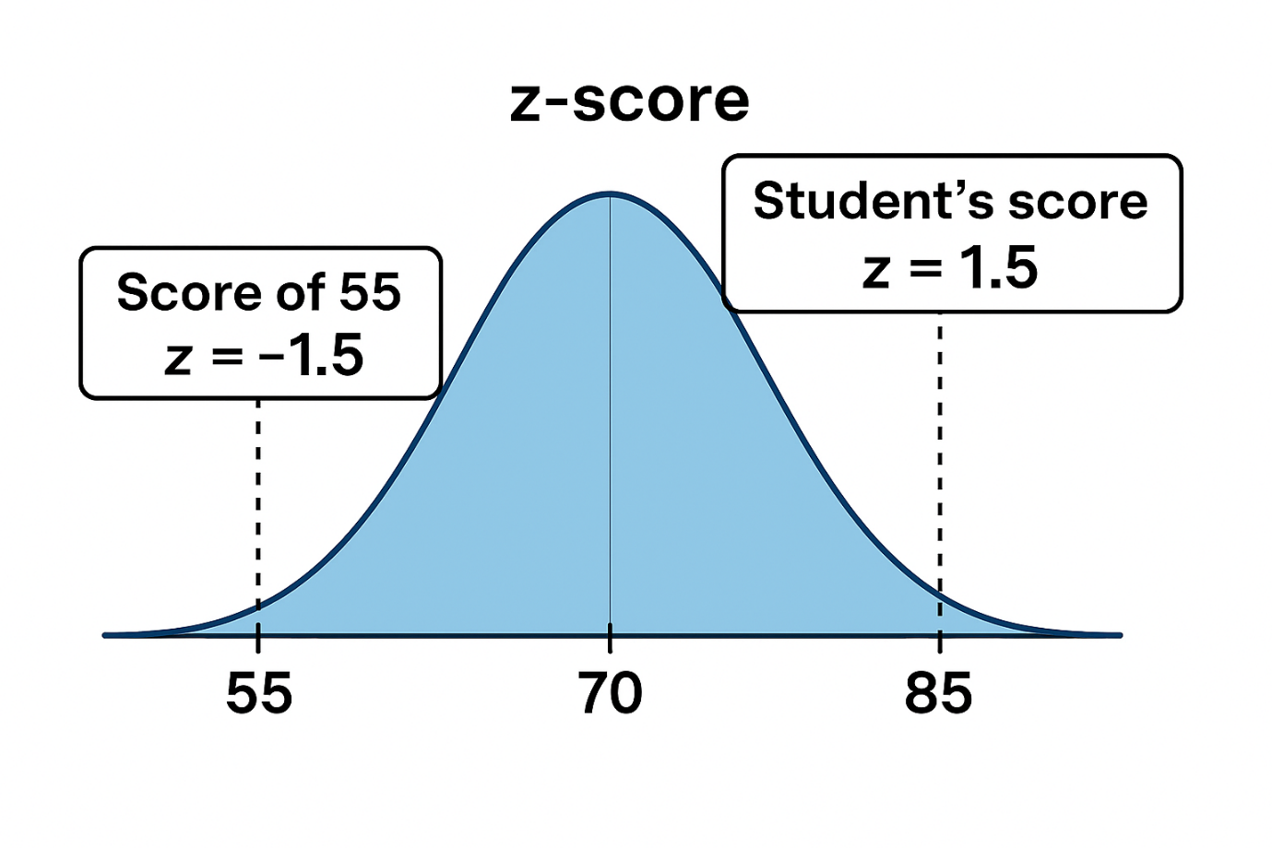This helps illustrate:
- Above-average performance: The student at 85 is in the top ~93% of the distribution.
- Below-average performance: The score of 55 falls in the bottom ~7%, showing how Z-Scores quantify relative standing.

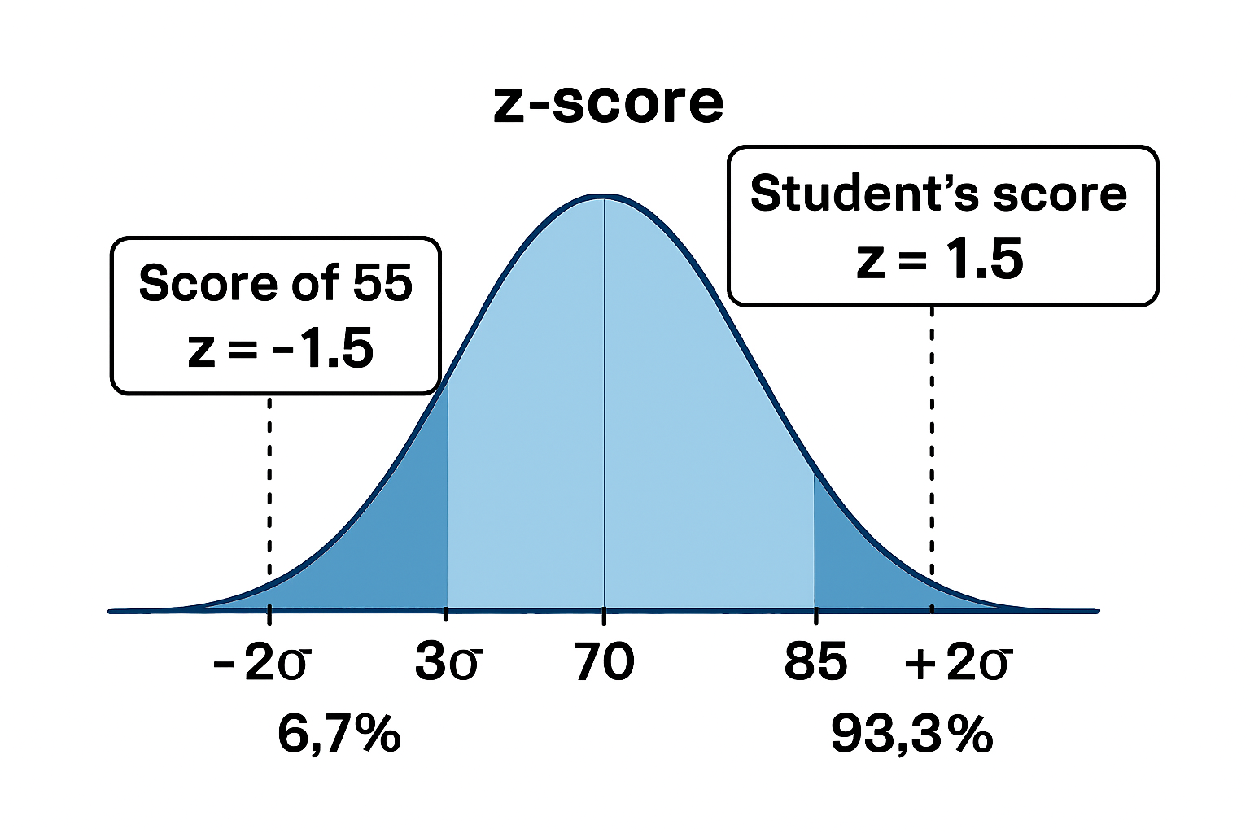
Here’s the enhanced visual diagram— now includes:
- Student’s score at +1.5σ (85)
- Below-average score at −1.5σ (55)
- Extended Z-Score labels for ±2σ and ±3σ zones
- Shaded percentile regions showing that the score of 85 places the student in the top 93.3%, while 55 falls in the bottom 6.7%
This gives a complete picture of how Z-Scores map onto real-world performance and percentile rankings.

